Setup Phonegap in Window System:

System Requirement:

1. Java development kit (JDK) and JRE : <http://www.oracle.com/technetwork/java/javase/downloads/index.html>
2. Android SDK   
   (http://developer.android.com/sdk/index.html#Other)
3. NodeJs :  
    http://nodejs.org/
4. Apache Ant : http://ant.apache.org/
5. Ruby setup :   
   https://www.ruby-lang.org/en/downloads/  
     
     
   **Step 1 :**  
   a) Install all above tools in your system

b) Then set **environment**variable for each one.

Just go My computer>Properties> Advanced Systems> Settings > **Environment**variables

See the screen shot

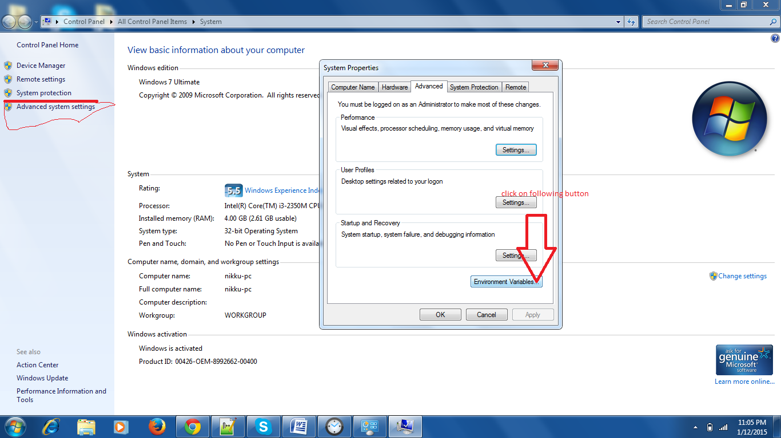

See the screen;

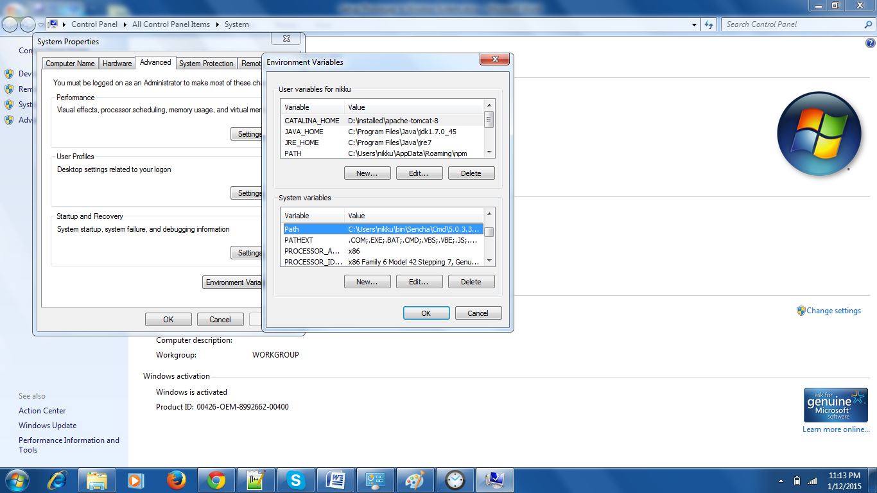

Select Path option in Systems Variables and Click on **EDIT** button.

c) Put the following path in there

**Java (JDK ):**   
C:\Program Files\Java\jdk1.7.0_45\bin

**Android SDk:**   
1) D:\installed\android-sdk\sdk\platform-tools

2) D:\installed\android-sdk\sdk\tools

**Apache ANT:**

D:\installed\apache-ant-1.9.4\bin  
  
**Ruby :**

C:\Ruby21\bin

Your string should be look like this in **PATH** :

C:\Program Files\Java\jdk1.7.0_45\bin; D:\installed\android-sdk\sdk\platform-tools; D:\installed\android-sdk\sdk\tools; D:\installed\apache-ant-1.9.4\bin; C:\Ruby21\bin

Step 2:

1. Open command prompt and type following command :

npm install cordova

you can also refer this link:

<http://cordova.apache.org/docs/en/4.0.0/guide_cli_index.md.html>

Then check you cordova version with following command:

cordova -v  
  
<http://cordova.apache.org/docs/en/4.0.0/guide_cli_index.md.html>

see “Test the App on an Emulator or Device” in above link.  
  
You can create virtual device : <http://www.embarcadero.com/starthere/xe5/mobdevsetup/android/en/creating_an_android_emulator.html>  
  
or you can also direct run app in real device by

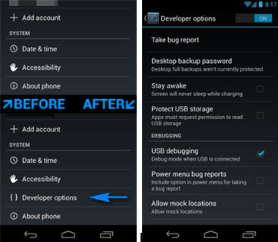  
  
with USB Debugging . you can easily compile your app in real device. Please turn on Debugging your device. And install mobogenie in you system : <http://www.mobogenie.com/in/> . then connect device with your system and see on mobogenie. If device in connected just go on command prompt and

Just go on app folder like :

* Cd D:\application\phonegap\rpm

And run following command

* D:\application\phonegap\ rpm **cordova run android**and then the app will see on you device.